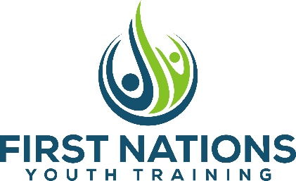
Blue Collar Silviculture, with funding provided by the Government of Canada through the Canada-BC Workforce Development Agreement, is offering the First Nations Youth Training Program to aboriginal youth between the ages of 18-29.

The Fall training program will be October 4 – 29th, 2021. The program will be based in Takla Landing, BC and are available to participants from throughout British Columbia.

This program combines work experience with short term certificate training. Each week is filled with classroom training and on-site work opportunities, and most weekends have organized recreational activities. Job placement support is provided to transition into long-term employment or new learning opportunities.

Interested participants must meet the following criteria:
- Be 18-29 years of age, possess photo ID and be in possession or either a SIN# or a Status Card
- Be Unemployed or does not have steady and secure employment
- Have completed grade 10 or equivalent
- Not a student
- Not participating in another provincial or federally funded labour market program
- Interested in securing employment in the resource or hospitality sectors

Room/board and transportation costs are covered for the duration of the program. Transportation can be arranged from your home community to and from Takla Landing.

The following training and work opportunities will be performed throughout the program:
SKILLS TRAINING
- S100/S185 | - Traffic Control | - Forklift Training
- CSTS | - Fall Protection | - Aerial Work Platform
- Driver Training | - Food Safe/ World Host | - Ground Disturbance
- OFA Level 1/Transportation Endorsement | - Resume Writing/Job Interview Skills | - Chainsaw Safety and Maintenance
- Career Decision Making | - GPS /Compass Orientation | - Confined Space Training

WORK OPPORTUNITIES
- Modular Camp Installation | - Camp Services: Line Cook and Maintenance
- Brushing and Spacing | - Recreation Site Management and Trail Maintenance

Please send inquires to: training@bluecollargroup.ca
Online application: http://www.bluecollargroup.ca/fnytpapplication.html
For more info: http://www.bluecollargroup.ca/fnytp.html
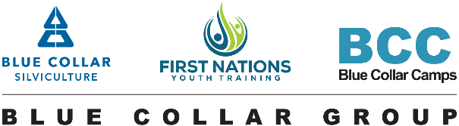
2021 Program Partners & Supporters:
Securiguard | Tolko Industries | Bob’s Driving School | SilvaGro Partnership
The Wells Hotel | West Fraser Mills | Redrock Camps | Timber Trek Consulting
Quesnel Chamber of Commerce | Barkerville Gold Mine | Summit Camps | Irwin’s Industrial Safety
Progressive Ventures | Horizon North | Quesnel Tillicum Society | Correlieu Secondary School

